Purchase Request: Reject/Short close. Capture the reason for Reject/Short close.
PO – Total amount is showing wrong. Instead of 1000 it shows only 100
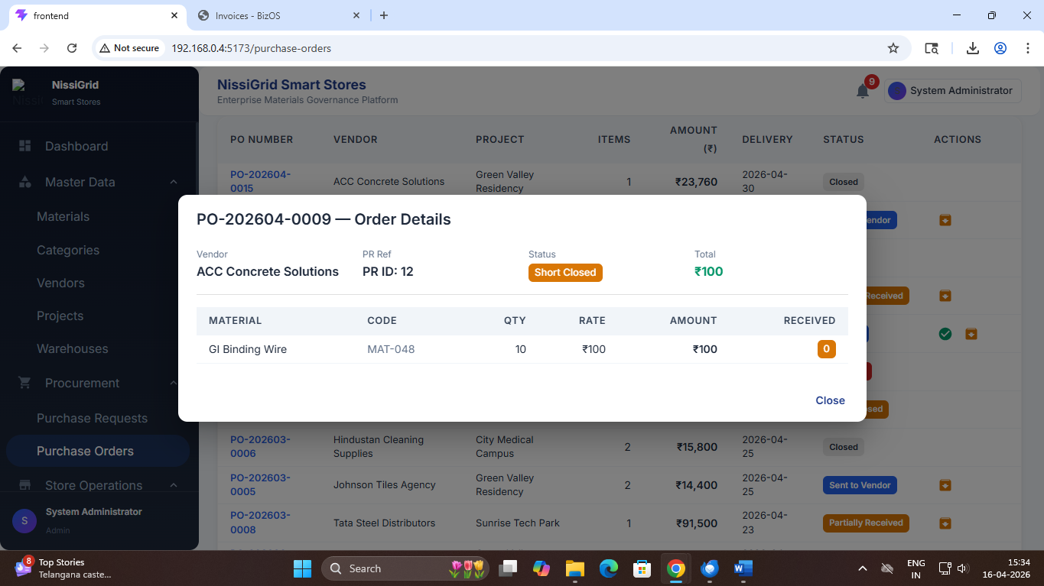

Gate Entry: Saving a Gate entry shows the message [object object]. Not able to create gate entry.
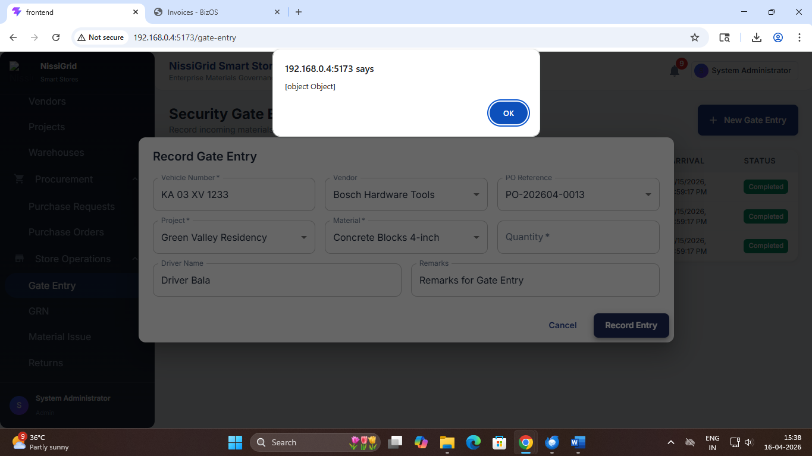

PO Convert to PO : During the PO conversion, it is showing the message “All approved PRs for project "Green Valley Residency" are listed below. Select the items to include in this PO.” And show all the other PR number and materials. Once the PR is approved, we need to have the approved PR materials to convert to PO. If you add any additional materials, it should go to approval process again. Otherwise, it’s like bypassing the approval process and the user can add any material with out approval for the PR. Later it is difficult to find out, if more than one number of materials are listed under same PR, which one is approved and which one is added later before PO conversion.

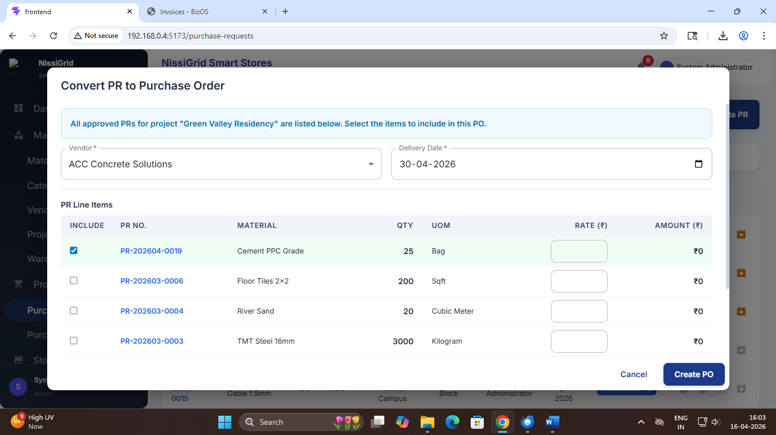
PR : Once Draft PR is approved, it moves to Approved Status; it should move to Submitted status instead of Approved Status
PR: There is no way to view the list of material and quantity listed in the PR. show the list as entered by the user. Wit out seeing these details, they will not approve.
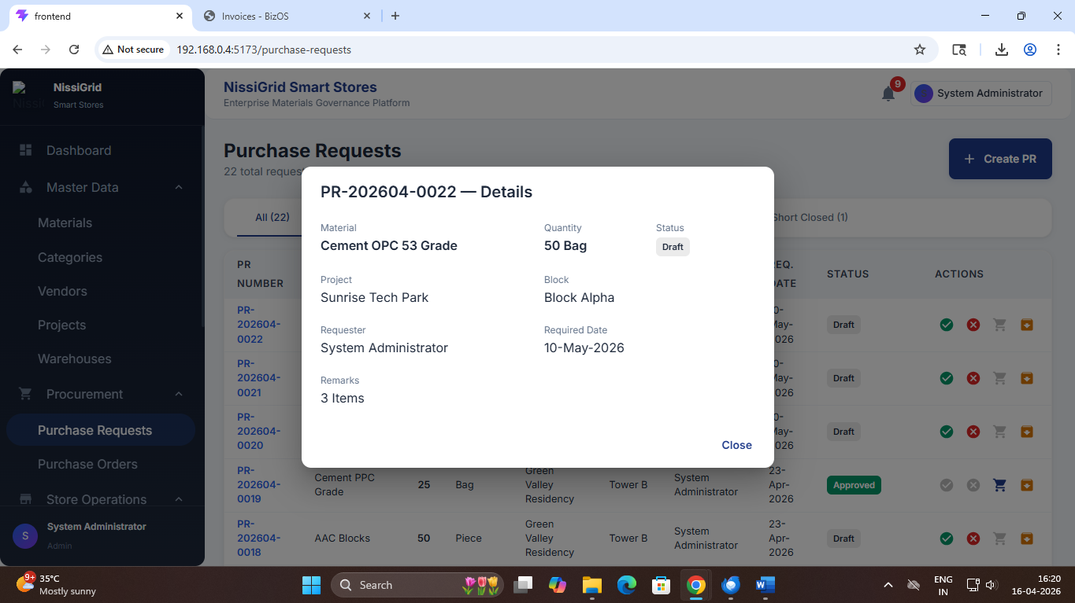
Show the PR date and PO Date respectively for PR and PO list/view
PO:
No validation for the number of quantities to put against a PO. It should validate the numbers should be equal or less the PO quantity.
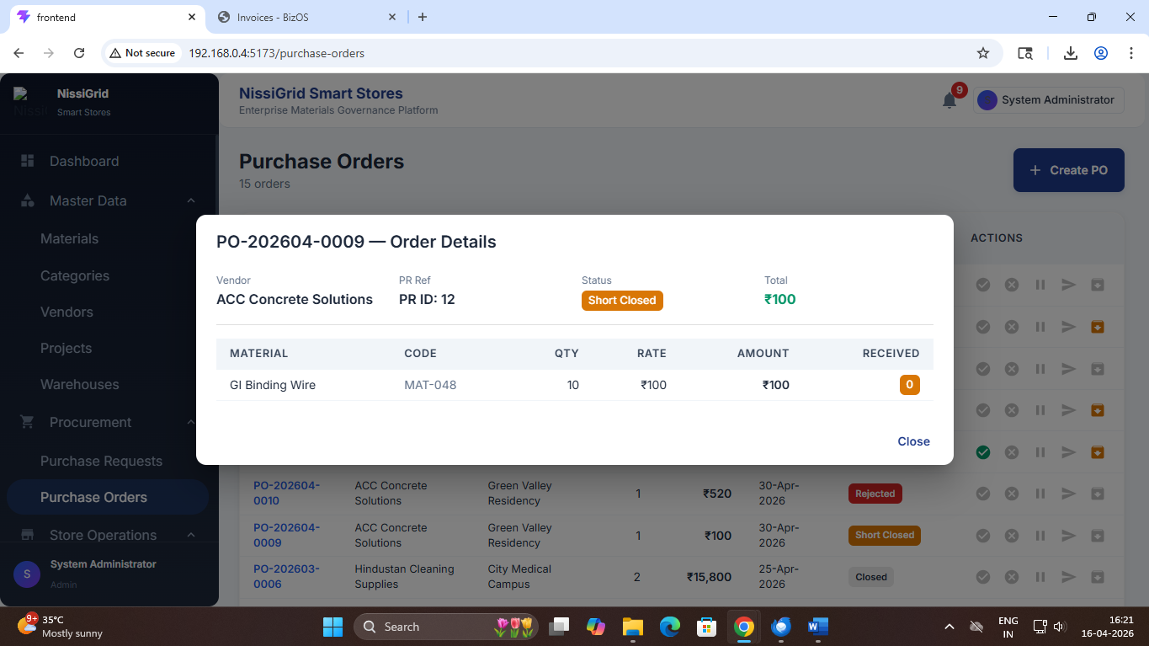
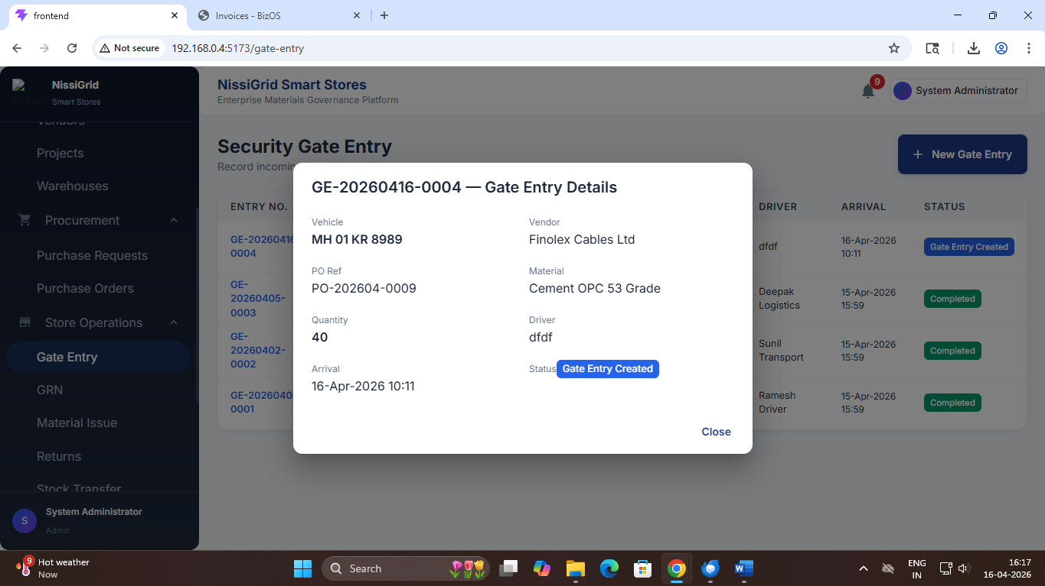
Once the gate pass is created, the received value should be updated in the PO also.
Partial Items: Items are delivered partially, already received and pending numbers to be updated based on the previous gate pass

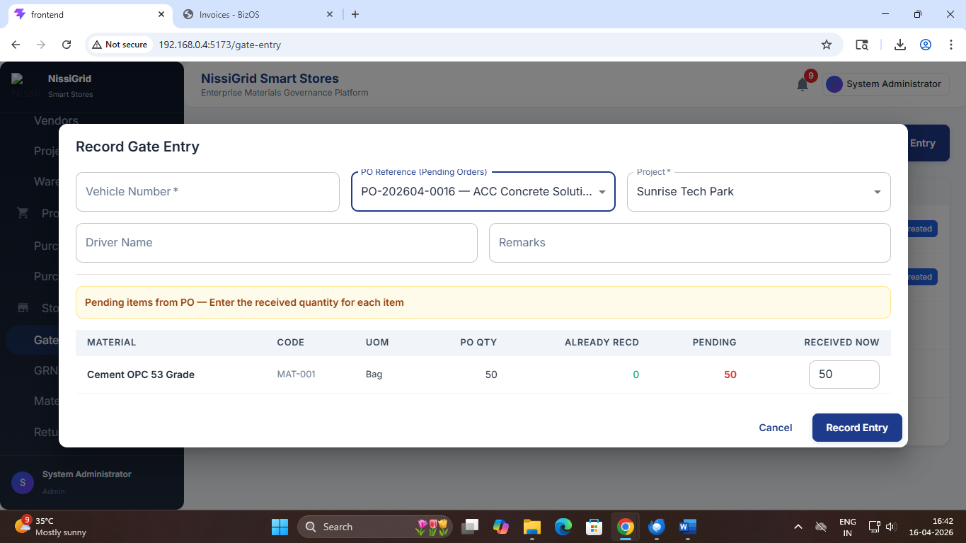

Gate Entry : Looks like vehicle number is mandatory as * is displayed next to field name. But it is accepting without that field values
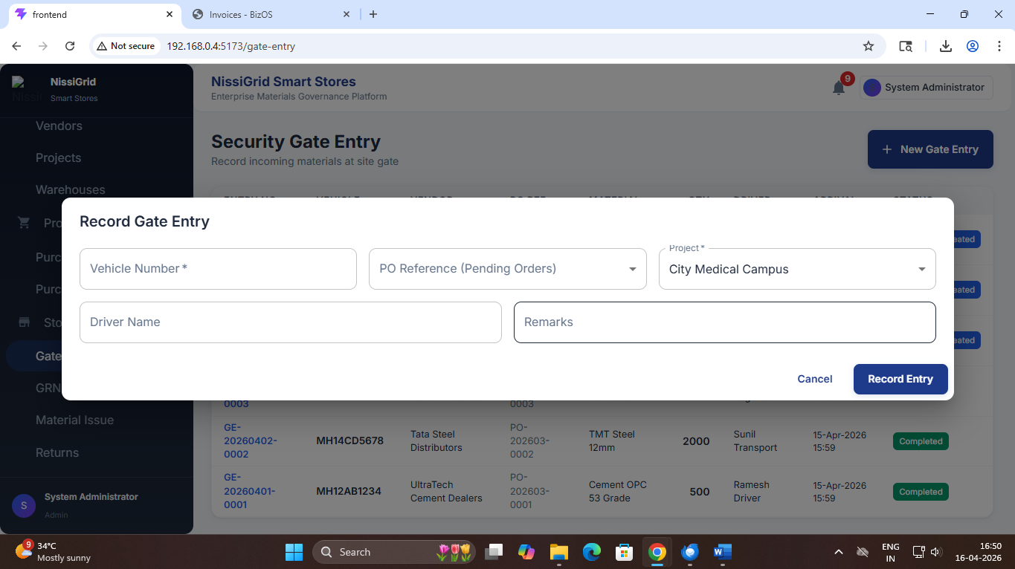

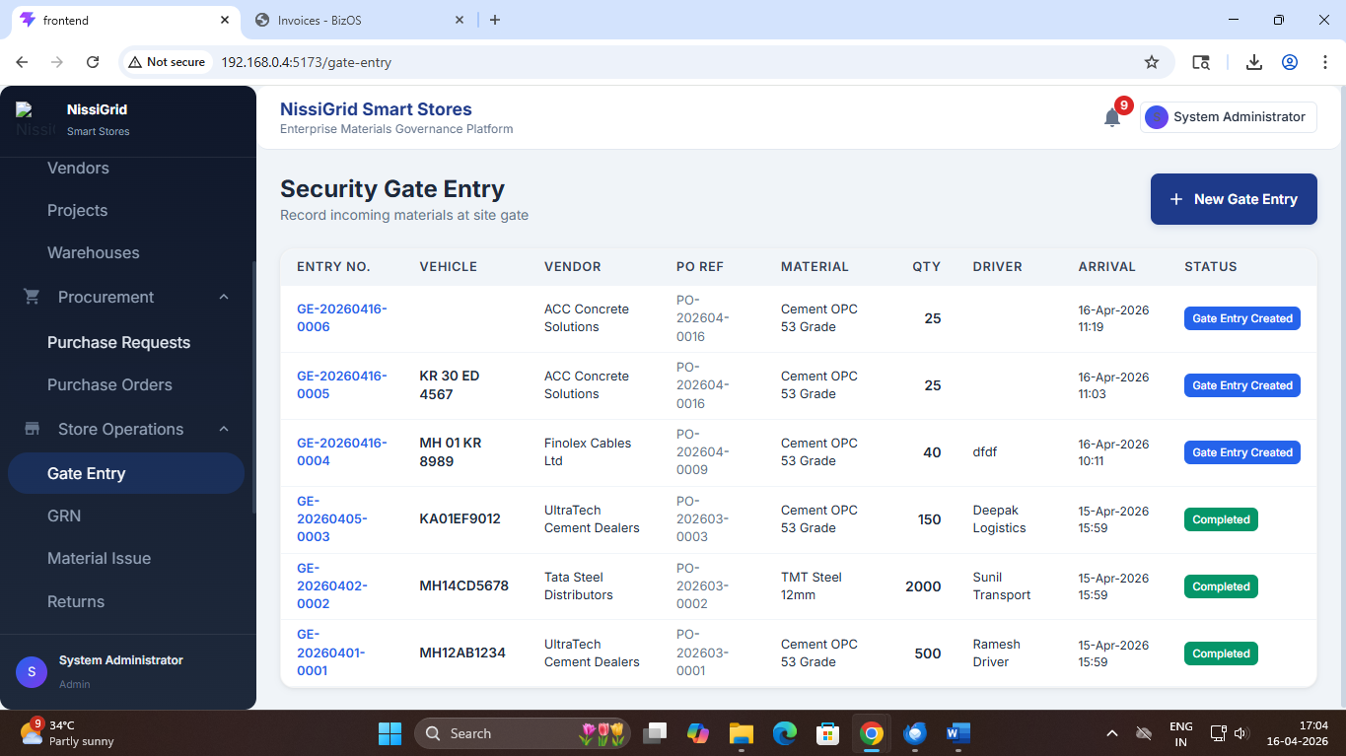
Show full PR ID
